H.T No
Regulations:
A22

Sreenidhi Institute of Science and Technology
(An Autonomous Institution)
Code No:9K511 Date: 23-January-2025 (AN)

B.Tech III-Year I- Semester External Examination, January-2025 (Regular)
STRUCTURAL ANALYSIS-II (CIVIL)

Time: 3 Hours Max.Marks:60

Note: a) No additional answer sheets will be provided.
b) All sub-parts of a question must be answered at one place only, otherwise it will not be valued.
c) Missing data can be assumed suitably.
Bloom's Cognitive Levels of Learning (BCLL)

Remember | L1 | Apply | L3 | Evaluate | L5
Understand | L2 | Analyze | L4 | Create | L6

Part - A Max.Marks: 6x2=12

Answer all QUESTIONS, EACH QUESTION CARRIES 2 MARKS.

 |  | BCLL | CO(s) | Marks
1 | List the applications of two hinged arches. | L1 | CO1 | [2M]
2 | State the assumptions of moment distribution method | L1 | CO2 | [2M]
3 | State the advantages of Kani’s method over the moment distribution method | L1 | CO3 | [2M]
4 | State assumptions made in the cantilever method. | L1 | CO4 | [2M]
5 | How do you assess the sizes of flexibility and stiffness matrices? | L1 | CO5 | [2M]
6 | What is moving load or rolling load? | L1 | CO6 | [2M]

Part – B Max.Marks: 6x8=48
ANSWER ALL QUESTIONS. EACH QUESTION CARRIES 8 MARKS.

 |  | BCLL | CO(s) | Marks
7. | Two hinged parabolic arch of span 36m and central rise 8m carries a uniformly distributed load of 32kN/m over the left half of the span. Determine the position and value of maximum bending moment | L3 | CO1 | [8M]
 | OR
8 | Determine the horizontal thrust developed in a parabolic arch of radius R and  concentrated load of W at the crown. | L3 | CO1 | [8M]
9. | Analyze the continuous beam by Moment distribution method as shown in Figure. Draw the bending moment diagram..  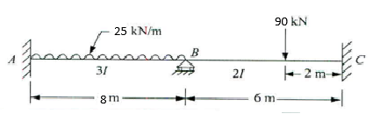  72KN  20KN/M | L4 | CO2 | [8M]
 | OR
10 | Analyze the portal frame as shown in Figure using Moment distribution method. Draw BMD.  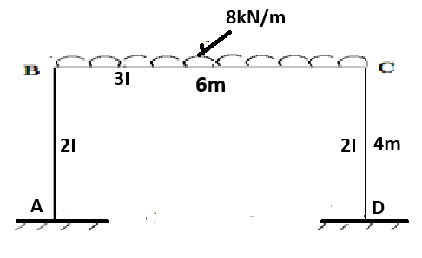 | L4 | CO2 | [8M]
11. | Analyze the continuous beam by Kani’s method. Draw the bending moment diagram,  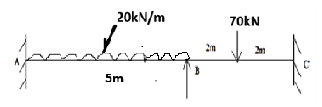 | L4 | CO3 | [8M]
 | OR
12 | Analyze the rigid portal frame by Kani’s method. Draw the bending moment diagram.  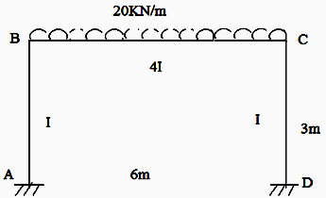 | L4 | CO3 | [8M]
13. | Analyze the frame shown in Figure by stiffness matrix method.  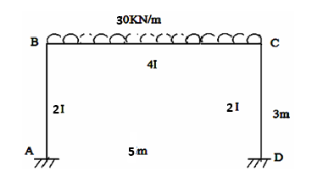 | L4 | CO4 | [8M]
 | OR
14 | Analyze the beam by Flexibility method shown in Figure.  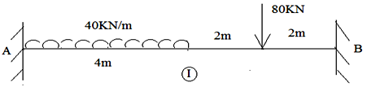 | L4 | CO4 | [8M]
15. | Illustrate the cantilever method using any example | L4 | CO5 | [8M]
 | OR
16 | Compare the portal method and cantilever method | L4 | CO5 | [8M]
17. | A train of Wheel loads as shown below crosses a span of 20m span with  30 kN load leading, the value of  i) Maximum positive and negative shear at mid span and  ii) Absolute maximum bending moment on the girder.  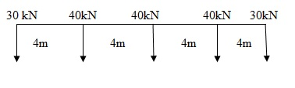 | L3 | CO6 | [8M]
 | OR
18 | A girder having a span of 30M is simply supported at its ends. It is  travelled by a train of loads 6KN, 11KN, 16KN, 21KN, and 7KN  spaced at 3M, 4M, 3M & 2M with 5KN load leading Calculate.  (i) Maximum positive Shear force (ii) The position & amount of maximum bending moment anywhere in the girder | L3 | CO6 | [8M]
-- 00 -- 00 –

